Nama : EMILIA SANTINI

NIM : 211001035

Kelas : 4D INFORMATIKA

2. Python-Modul 1

* Baris dan Indentasi



* Pernyataan Multibaris

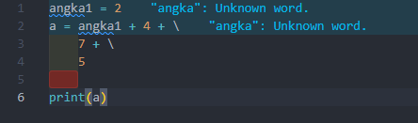

* Statement Dalam Tanda Kurung



* Tanda Kutip







* Kode Operator Aritmatika

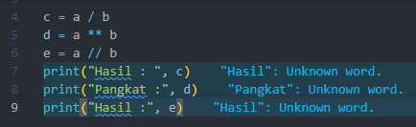

* Kode Operator Perbandingan

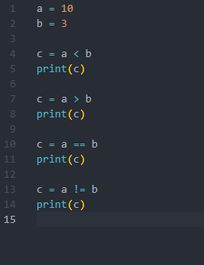

* Kode Operator Penugasan

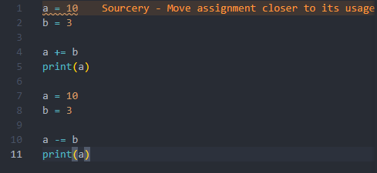

* Kode Operator Logika

* Kode Operator Bitwise

* Kode Operator Identitas

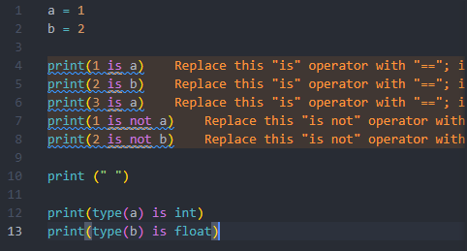

* Kode Operator Keanggotaan

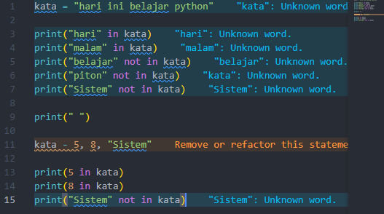

3. Python-Modul 2

* Kode Output

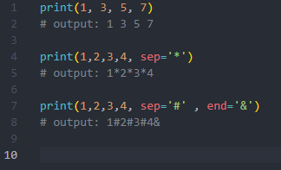

* Kode Input

* Kode Input Integer Tanpa Fungsi int()



* Fungsi int() Cara Pertama

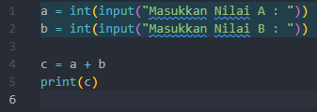

* Fungsi int() Cara Kedua

* Fungsi float()

* Fungsi abs() Statis

* Fungsi abs() Dinamis

* Fungsi pow() Statis

* Fungsi pow() Dinamis

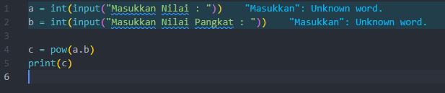

* Fungsi sqrt() Statis

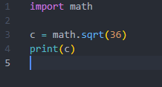

* Fungsi sqrt() Statis

* Fungsi Lain

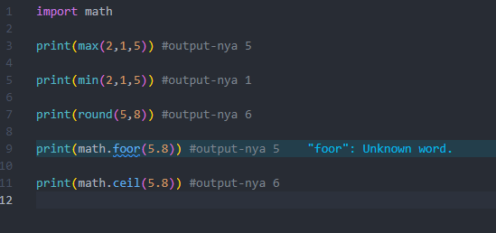

* Fungsi len()

* Fungsi index()

* Fungsi Lain

* Range Slice

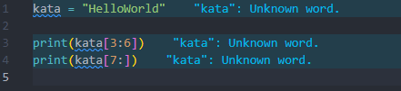

* Mengakses Anggota List

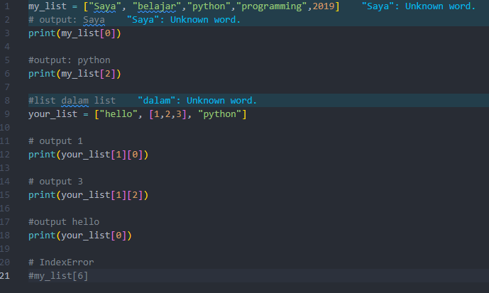

* List Dengan Indeks Negatif

* Memotong List

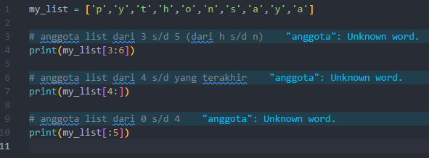

* Mengubah Anggota List

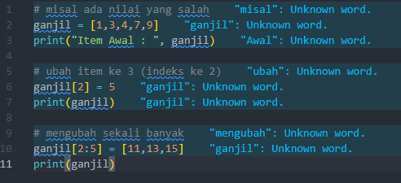

* Menambah Anggota List

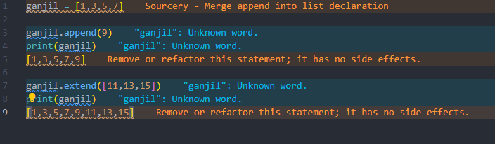

* Menggabung List dengan Operator

* Menyisipkan Anggota List

* Menghapus Anggota List

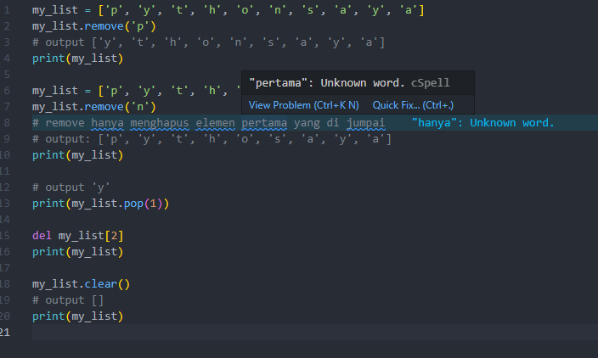

* Mengurutkan Anggota List

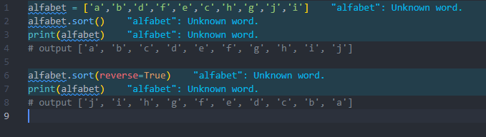

* Membalik Urutan List

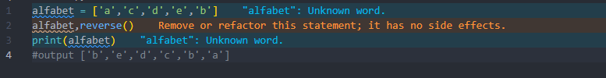

4. Python-Modul 3

* Membuat Tuple

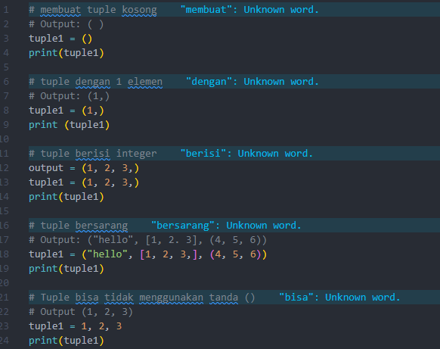

* Mengakses Tuple

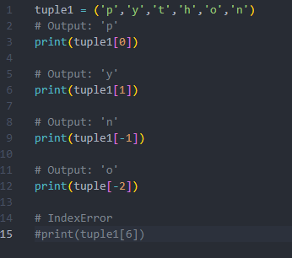

* Mengakses Tuple dengan Range

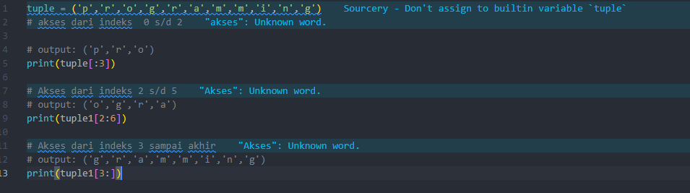

* Mengubah Anggota Tuple

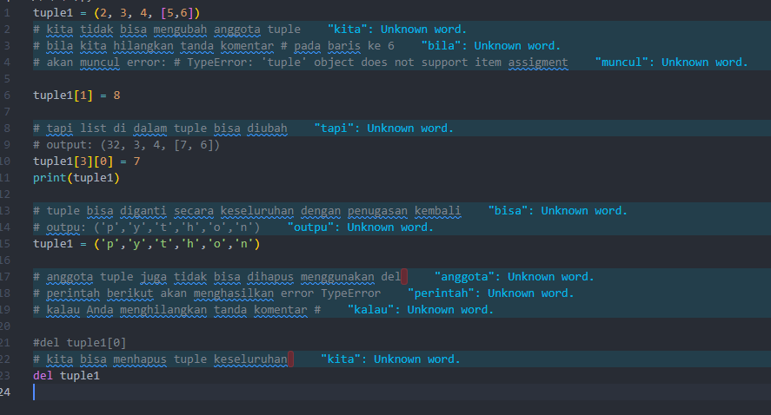

* Mengubah Anggota Tuple

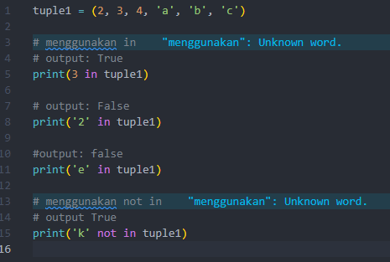

* Iterasi pada Tuple

* Fungsi Bawaan Tuple

* Membuat Set

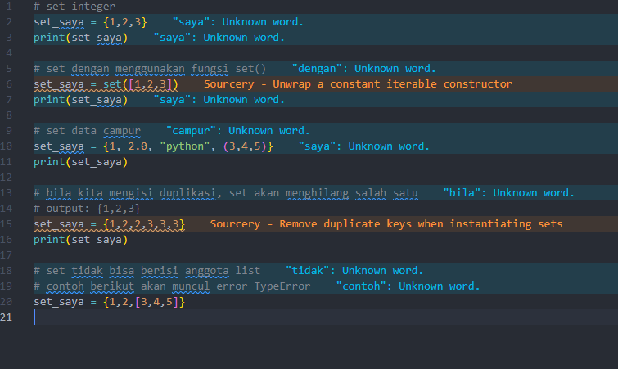

* Set Kosong

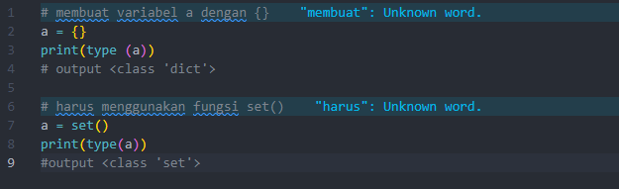

* Mengubah Anggota Set

* Menghapus Anggota Set

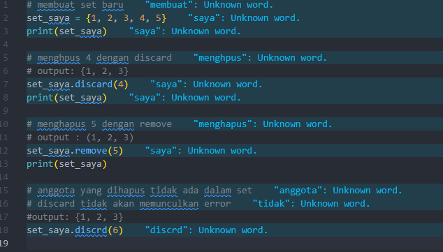

* Menghapus Anggota Set Secara Random dengan pop()

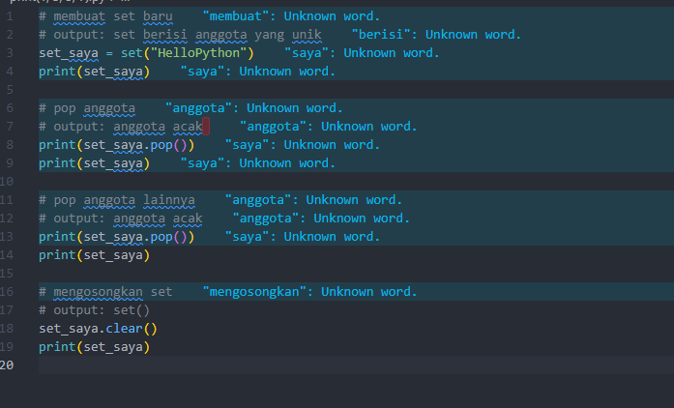

* Operasi Gabungan (Union) dengan Set

* Operasi Irisan (Intersection) dengan Set

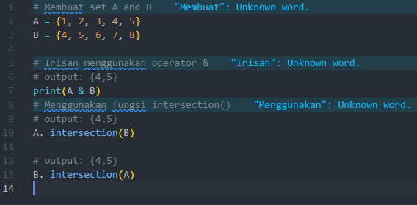

* Operasi Irisan (Intersection) dengan Set

* Operasi Komplemen (Symmetric Difference) dengan Set

* Membuat Dictionary

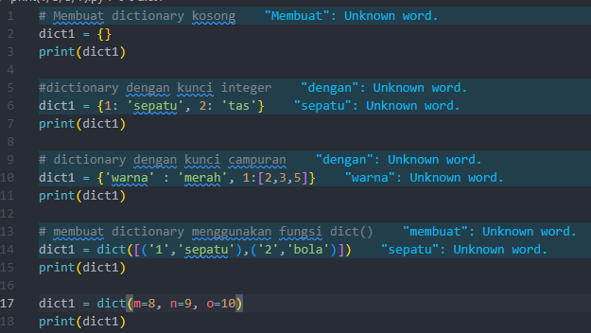

* Mengakses Anggota Dictionary

* Mengubah Anggota Dictionary

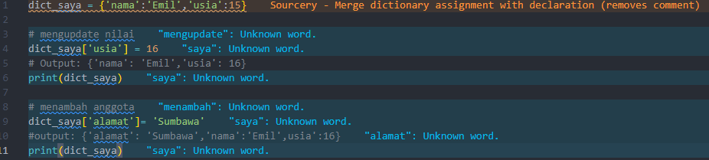

* Menghapus Anggota Dictionary



